

OSEHRA Certification

%ut - A Unit Tester For M Code

Version 4

April 11, 2015

Revision History

| Date | Revision | Description | Author |
| --- | --- | --- | --- |
| 07/31/14 | 0.1 | Draft | Joel Ivey |
| 08/06/14 | 1.0 | Initial Publication | Joel Ivey |
| 08/29/14 | 1.0 | Revision | Joel Ivey |
| 08/10/15 | 1.1 | Revision | Joel Ivey |
| 09/14/15 | 1.2 | Revision | Joel Ivey |
| 12/12/15 | 1.3 | Revision – Coverage for Cache | Joel Ivey |
| 04/11/16 | 1.4 | Revision – Corrections during install, addition of Verbosity value of 2 turns on timeing of each test | Joel Ivey and Sam Habiel |

Table of Contents

1. Purpose 1

2. Scope 1

3. Introduction to mUnit M–Unit Testing 1

3.1. Getting Started 2

3.2. M–Unit Test Dos and Don'ts 7

3.3. M–Unit Test Definitions 7

4. MUnit.exe 11

5. Installation of the M–Unit Software 14

6. Running M-Unit Tests 16

Table of Figures

Figure 1. Selection of an M-Unit test 11

Figure 2. List of Unit tests selected for running 12

Figure 3. The unit tests run with failures 12

Figure 4. Specifics on failed tests or errors 13

Figure 5.Specification of unit tests by routine name 13

Figure 6. Result from the second group of unit tests 14

%ut - A Unit Tester For M Code

1. Purpose

This document describes M–Unit Test, a tool that permits a series of tests to be written to address specific tags or entry points within a project and act to verify that the return results are as expected for that code. If run routinely any time that the project is modified, the tests will act to indicate whether the intended function has been modified inadvertently, or whether the modification has had unexpected effects on other functionality within the project. The set of unit tests for a project should run rapidly (usually within a matter of seconds) and with minimal disruption for developers. Another function of unit tests is that they indicate what the intended software was written to do. This can be especially useful when new developers start working with the software or a programmer returns to a project after a prolonged period. Ensuring that well-designed unit tests are created for each project, therefore, assists development, enhances maintainability and improves end-user confidence in the deployed software.

The concept of Unit Testing was already in place before Kent Beck created a tool that he used in the language Smalltalk, and then was turned into the tool Junit for Java by Kent Beck and Erich Gamma. This tool for running specific tests on facets of a software project was subsequently referred to as xUnit, since NUnit was developed for .NET developers, DUnit for Delphi developers, etc. MUnit is the equivalent tool for M developers to use and was originally created in 2003.

1. Scope

This document describes the use of the M–Unit Testing tools for building and running unit tests for M code. It also describes the installation of the M–Unit Test software.

1. Introduction to M–Unit Testing

A Unit Test framework permits small tests to be written to verify that the code under examination is doing what you expect it to do. Generally, the tests are performed on the smaller blocks of the application, and do not necessarily test all of the functionality within the application. These tests can be run frequently to validate that no errors have been introduced subsequently as changes are made in the code. The concept of automated Unit testing was introduced by Kent Beck, the creator of eXtreme Programming methodology, with a tool used in the language Smalltalk. The common JUnit framework for Java, upon which other frameworks are based, was written by Kent Beck and Erich Gamma. The phrase 'Test-Driven Development' is frequently used to indicate the strong use of unit testing during development, although some think of it as equivalent to 'Test First' development, in which the tests for code are written prior to writing the code. In Test First Development, the test should initially fail (since nothing has been written) and then pass after the code has been written.

For client side languages, JUnit (for Java), DUnit (for Delphi), NUnit and HarnessIt (for dotNet) all provide Unit Test frameworks. The routines %ut, %ut1 and %utcover, included in this version, provide the same capabilities for unit testing M code and, previously supported only on GT.M systems, the current version analyzing coverage of the code base by unit tests in both GT.M and Cache systems. Initially, the client side tests were console based (i.e., not windows, but just text), and that is what %ut provides. For those who like pretty windows, there is an optional GUI front end, MUnit_OSEHRA.exe, available for use (the GUI application does not currently provide display of the coverage analysis).

* 1. Getting Started

If you are going to modify sections of your code, or refactor[1], it is best to create a unit test for those areas with which you want to work. Then the unit tests can be run as changes are made to insure that nothing unexpected has changed. For modifications, the unit tests are then written to reflect the new expected behavior and used to insure that it is what is expected. One of the major benefits of unit testing is finding those changes in other parts of your code due to the changes that the modified code made.

The following is a very simple sample routine that covers everything necessary for generating a basic unit test and includes examples of the various calls available:

XXXX ;jli/jiveysoft - demo code for a unit test routine ;8/05/15 15:44

;;

; makes it easy to run tests simply by running this routine and

; insures that %ut will be run only where it is present

I $T(EN^%ut)'="" D EN^%ut("XXXX")

Q

;

STARTUP ; optional entry point

; if present executed before any other entry point any variables

; or other work that needs to be done for any or all tests in the

; routine. This is run only once at the beginning of processing

; for the routine (This is modified from the prior version, which

; ran it only once for all processing).

Q

;

SHUTDOWN ; optional entry point

; if present executed after all other processing in the routine is

; complete to remove any variables, or undo work done in

; STARTUP.

Q

;

SETUP ; optional entry point

; if present it will be executed before EACH test entry in the

; routine to set up variables, etc.

Q

;

TEARDOWN ; optional entry point

; if present it will be executed after EACH test entry in the routine

; to clean up variables, etc.

Q

;

ROUNAME ;;LOC/ID-DESCRIPTION; DATE

;;VER;PKG;;;;

; Example of calling test at top of routine so they can be run easily

I $T(EN^%ut)'="" D EN^%ut(“TESTROU”)

; D EN^%ut(“TESTROU”,1) ; used for verbose output

; D EN^%ut(“TESTROU”,2) ; used for verbose output with timing

;

ENTRY1 ; Example for use of CHKEQ call to check two values

;

; code to generate a test, e.g. to check the sum of 1 and 1

S X=1,Y=1

D CHKEQ^%ut(2,X+Y,"1+1 didn't yield 2") ;

;

; usage of CHKEQ^%ut

; first argument is the expected value

; second argument is the actual value

; third argument is text to be displayed if the first argument

; and second argument are not equal.

;

; Multiple calls to CHKEQ^%ut may be made within one entry

; point. Each of these is counted as a test.

;

; Output for a failure shows the expected and actual values

; and the message text, if any is supplied.

Q

;

ENTRY2 ; Use of CHKTF call to check value for True or False

;

S ERRMSG="Current user is not an active user on this system"

D CHKTF^%ut($$ACTIVE^XUSER(DUZ)>0,ERRMSG)

;

; usage of CHKTF^%ut

; first argument is an expression evaluating to true or false value,

; second argument is text to be displayed if the first argument

; evaluates to false.

;

; Multiple calls to CHKTF^%ut may be made within one entry

; point. Each of these is counted as a test.

;

; Output for a failure shows the message that has been input

; with the test value.

Q

;

ENTRY3 ; Use of CHKTF call to check values that should NOT be equal

;

; if you want to test something that should fail, use a NOT

S X=1,Y=3

D CHKTF^%ut(X'=Y,"indicated 1 and 3 are equal")

Q

;

; Note the @TEST on the line with the following tag, it indicates

; that the tag is a unit test entry , the text following the @TEST

; indicator is used as a description for the test.

ENTRY4 ; @TEST - Use of the FAIL call to generate a failure message

;

; This API is used when code shouldn't be encountered, or some

; other condition results that is considered a failure without

; determining whether values are equal, or true/false conditions

; exist.

S X=1+2 I X'=3 D FAIL^%ut("System is doing bad addition on 1+2") Q

;

; usage of FAIL^%ut

; the argument is text indicating why the failure was identified

Q

;

; The following code would normally be encountered in the code

; under test, but is included to show the use of the ISUTEST API

ENTRY5 ;

S VALUE=1 ; a default value for use during unit tests

I $T(ISUTEST^%ut)'="",'$$ISUTEST^%ut() R !,"Enter a value: ",VALUE:$G(DTIME,300)

;

; $$ISUTEST^%ut() is used to determine whether the code is being

; run as a part of a unit test, and may be used to use a default

; value instead of asking the user to enter a specific value, etc.

; Unit tests should impact production code as little as possible,

; but this API does offer a means for determining whether it is

; being run in a unit test or not.

;

;

; Other routine names to be included in testing are listed one per line

; with the name as the third semi-colon piece on the line and an

; optional description of what the routine tests as the fourth semi-

; colon piece, if desired this permits a suite of test routines to be

; run by simply starting one of the routine the names may be repeated

; in multiple routines, but will only be included once. The first line

; without a third piece terminates the search for routine names (which

; is why this is above the XTROU tag).

XTROU ;

;;XXXY;description of what the routine tests

;;XXXZ;

;;XXXA

;

; Entry points for tests are specified as the third semi-colon piece,

; a description of what it tests is optional as the fourth semi-colon

; piece on a line. The first line without a third piece terminates the

; search for TAGs to be used as entry points

XTENT ;

;;ENTRY1;tests addition of 1 and 1

;;ENTRY2;checks active user status

;;ENTRY3;

Q

Running XXXX as written above results in the following:

>D ^XXXX

Referenced routine XXXY not found.

Referenced routine XXXZ not found.

Referenced routine XXXA not found.

...

Ran 1 Routine, 4 Entry Tags

Checked 3 tests, with 0 failures and encountered 0 errors.

>

You will not normally see routines that aren't there referenced, since you would not include them. By default, passed tests are shown only with a dot and the results are summarized at the bottom.

To illustrate a failure, change the code on line ENTRY+3 from (X'=Y) to (X=Y). Running XXXX shows that the test now fails. The location of the tag and the comment for failure are shown in the order of the tests:

>D XXXX

Referenced routine XXXY not found.

Referenced routine XXXZ not found.

Referenced routine XXXA not found.

..

ENTRY3^XXXX - indicated 1 and 3 are equal

Ran 1 Routine, 4 Entry Tags

Checked 3 tests, with 1 failure and encountered 0 errors.

>

Now change the code on line ENTRY1+3 so that S X=1,Y=1 becomes X=1,Y=1 (removing S<space>. Running XXXX again identifies the error generated due to our typing, as well as continuing on to show the failure we introduced at ENTRY3. The test at ENTRY2 still runs without a problem, as indicated by the lone dot.

>D XXXX

Referenced routine XXXY not found.

Referenced routine XXXZ not found.

Referenced routine XXXA not found.

ENTRY1^XXXX - tests addition of 1 and 1 - Error: ENTRY1+3^XXXX:1, %DSM-E-COMAND,

bad command detected

.

ENTRY3^XXXX - indicated 1 and 3 are equal

Ran 1 Routine, 4 Entry Tags

Checked 3 tests, with 1 failure and encountered 1 error.

>

If the code at ENTRY4+2 is now modified to S X=1+1 and running it causes the FAIL call to be used.

>D XXXX

Referenced routine XXXY not found.

Referenced routine XXXZ not found.

Referenced routine XXXA not found.

ENTRY1^XXXX - tests addition of 1 and 1 - Error: ENTRY1+3^XXXX:1, %DSM-E-COMAND,

bad command detected

.

ENTRY3^XXXX - indicated 1 and 3 are equal

ENTRY4^XXXX - example of FAIL^%ut call - System is doing bad addition on 1+2

Ran 1 Routine, 4 Entry Tags

Checked 4 tests, with 2 failures and encountered 1 error.

>

Restoring S<space> on line ENTRY1+3, and changing X=1 to X=2 and running it shows the output of the CHKEQ call.

>d XXXX

Referenced routine XXXY not found.

Referenced routine XXXZ not found.

Referenced routine XXXA not found.

ENTRY1^XXXX - tests addition of 1 and 1 - <2> vs <3> - 1+1 didn't yield 2

.

ENTRY3^XXXX - indicated 1 and 3 are equal

ENTRY4^XXXX - example of FAIL^%ut call - System is doing bad addition on 1+2

Ran 1 Routine, 4 Entry Tags

Checked 4 tests, with 3 failures and encountered 0 errors.

>

In the early days of M-Unit work, the unit test routines were generated with the first four characters of their name as ZZUT. This was chosen so that the routines would not normally be exported with a package, because the developers who worked with the routines were generally working in the same account.

However, the routines **SHOULD** be included in builds so that others may also insure, using the unit tests, that the routines are running correctly. And, in an open source world, that others may work to extend the current work using the unit tests that were generated. For this reason, unit tests should be given the same namespace as other routines in the build, and included as a part of the build. If a four character namespace were NMSP, it is recommended that unit test routines be given the namespace NMSPU followed by characters to indicate the specific code they are related to.

Unit tests should run rapidly, so that they can be run and not impact the developer's (or tester's) time. If they take more than a few seconds to run, they may be put off until later or not run at all. If all of the tests are taking longer than a few seconds to run, then identify the tests that are taking longer. Running the tests in verbose mode when they are taking a long time will make the longer running tests easily identifiable as they run. And the current version includes, thanks to Sam Habiel, the ability to actually determine the length of time that the individual unit tests are taking. Using the EN^%ut API call for the unit test routine with a value of two as the second argument (VERBOSITY), will output the times in milliseconds for each unit test. Once long running unit tests have been identified, modify the unit tests so they will test the specific code for testing in a quicker manner. For example, if code is present that performs an analysis on each entry in a file, then the unit test should be set up to isolate the analysis itself, and then test performing the analysis on one or two selected entries in the file instead of all of them.

That covers the basics of generating a unit test routine to use with %ut. For sections of code performing calculations, etc., this is all that will be required. For other cases, depending upon database interactions or of input and output via something like the RPCBroker, other approaches to creating usable tests are required. These 'objects,' which can be used for consistency in such units tests, are generally referred to as 'Mock Objects.'

* 1. M–Unit Test Dos and Don'ts

You do not want to include any code which requires user input. You want the tests to be able to run completely without any user intervention other than starting them. By referencing other, related unit test routines within the one that is started, you can build suites of tests that can be used to cover the full range of your code.

* 1. M–Unit Test Definitions

Supported References in %ut are EN, CHKTF, CHKEQ, FAIL, CHKLEAKS, ISUTEST, RUNSET, COV, COVERAGE, MULTAPIS, GETUTVAL, and LSTUTVAL. It should be noted that COV was previously available in %ut1, and was moved to %ut so all supported references could be accessed in %ut (without challenging memories). The supported references COVERAGE, MULTAPIS, GETUTVAL, and LSTUTVAL were added as new functionalities in the previous version.

The entry point EN^%ut(ROUNAME,VERBOSE,BREAK) starts the unit testing process. The first argument is required and provides the name of the routine where the testing should be started. That routine must have at least one test entry point (and possibly more) either specified in the line(s) immediately following the tag XTENT as the third semi-colon piece on the line OR it can have tags with @TEST as the first text of the comment for the tag line. The second argument (optional) is VERBOSE - if it evaluates to true (e.g., 1) will turn on verbose mode, which lists each individual test being run as well as its result. If the VERBOSE argument has a value of two, it will output in verbose mode, and include the time that each of the unit tests take to run. The third argument (optional) is BREAK - if it evaluates to true it will cause the M-Unit Test process to terminate upon a failure or error instead of continuing until all tests have been evaluated before finishing, as it normally does. While some individuals like this capability, and it has been left in for those individuals, it is not recommended since any errors encountered during the testing will be recorded and all other tests should be permitted to run to conclusion. It can be useful however, in those cases where a unit test is getting into an infinite loop to break the processing and identify where the problem is.

A test is performed on a conditional value by calling the entry point CHKTF^%ut(testval,messag) with the first argument the conditional test value (true or false) and the second argument a message that should be displayed indicating what failed in the test.

A test checking two values for equivalence is performed by using the entry point CHKEQ^%ut(expected,actual,messag) with the first argument the expected value, the second argument the actual value, and the third argument the message for display on failure.

The entry point FAIL^%ut(messag) is used to simply generate a failure with the argument as the message to be displayed for the failure. This is normally used in a section of code that would not be expected to be processed.

The entry point DO CHKLEAKS^%ut(CODE,TESTLOC,.NAMEINPT) can be used within unit tests or in a stand alone test for variable leaks (those variables which are created within called code that are allowed to leak into the calling environment, unintentionally). The CODE argument would contain a command to be executed in the test for leaks (e.g., "S X=$$NOW^XLFTD()"). The TESTLOC argument would indicate the location under test for output and identification purposes (e.g., "$$NOW^XLFDT() leak test" or simply "$$NOW^XLFDT"). The NAMEINPT variable is passed by reference, and is an array which contains a list of all variables that the user is passing in and/or expects to be present when the code is finished (the variable X would be in the latter category, since it would then be present). The input is in the form of an array NAMEINPT("VARNAME")="VARVALUE", where VARNAME is the name of a variable, and VARVALUE is the value that is to be assigned to the variable before the contents of CODE is to be executed. When run in a unit test environment, variables that are present after the contents of CODE is executed that were not included in NAMEINPT as variables, will be listed as failures. When called outside of a unit test environment, any leaked variables will be listed on the current device.

The entry point ISUTEST^%ut is an extrinsic function used as S X=$$ISUTEST^%ut, and if a unit test is currently running, it will return a value of 1, otherwise it returns a value of zero. This can be used to select code to be run based on whether it is currently being tested (or something else that calls it is being tested).

The entry point COV^%ut provides coverage analysis this was previously available only on GT.M systems, however, the current version provides the same functionality for Cache systems as well. Usage is DO COV^%ut(NAMESPAC,CODE,VERBOSITY), where the argument NAMESPAC indicates the routine namespace to be analyzed. If NAMESPAC is only a routine name, only that routine will be included in the analysis. If NAMESPAC includes a terminal asterick (e.g., "NAMESP*"), then all routines which begin with the specified characters will be included in the analysis. The argument CODE is the code to be executed when running the analysis (e.g., "D EN^%ut(""ROUTINE"")"). This code will be run and coverage of the routines involved will be tracked, and those within the namespace indicated will be shown to the user. The third argument, VERBOSITY, determines how much information will be shown to the user. A value of 1 will show only the total coverage (number of lines covered out of total number of lines and a percentage) for each routine in the namespace specified as well as the totals for all routines analyzed. A VERBOSITY value of 2 will show that information as well as the coverage values for each tag within the routines. A VERBOSITY value of 3 will show the information from 1 and 2, and displays the actual lines under each tag that were NOT covered in the analysis. The latter can be quite a bit of information.

The entry point COVERAGE^%ut was added to handle those cases where there may be a number of different ways in which the unit tests are run, for example from the EN^%ut("ROUTINE") call; from a call to the top level of a production routine which then calls the unit test routine; and from a separate call within the production routine to run a verbose version of the unit tests, as well as adding the ability to specify routines in the namespace that should be ignored (we aren't really interested in the coverage of the unit test routines). The usage is

DO COVERAGE^%ut(NAMESPAC, .TESTROUS,.XCLUDE,VERBOSITY)

where the first and fourth arguments are the same as for the COV^%ut entry point.

The second argument is an array passed by reference where the subscripts and/or values may specify routines or APIs to be run in the overall analysis.

SET TESTROUS(1)="TESTURO1,EN1^TESTROU1,^TESTROU2"

SET TESTROUS("VERB^TESTROU2")="TESTURO2,TESTURO3"

Any routine reference without a '^' would be run as a call to EN^%ut with the routine name as argument, those with a '^' character would be run as simple DO commands (e.g, D ^TESTROU2 and D VERB^TESTROU2). All commands specified will be processed as part of a single analysis, and if subsequent tests attempt to start a coverage analysis, they will simply be included with the current analysis (previously they would remove previously collected data). The TESTROUS example above would result in six different unit tests being launched as a part of the overall coverage analysis.

The third argument is an array passed by reference where the routine names that are to be excluded from the analysis are specified as subscripts for the array and/or as comma separated list of routine names in the array values.

SET XCLUDE("TESTURO1")="TESTURO2,TESTURO3"

SET XCLUDE(1)="TESTURO4"

This array would cause four unit test routines to be excluded from the analysis generated.

The entry point MULTAPIS^%ut was provided to permit multiple unit tests to be run in the same manner as with the COVERAGE^%ut API, but without the coverage analysis. The usage is

DO MULTAPIS^%ut(.TESTROUS)

where the argument is the same as the second argument in the COVERAGE^%ut call. Since coverage analysis is not involved, namespace, exclusions, and verbosity (at least of coverage analysis) are not necessary.

The GETUTVAL^%ut API is provided for those cases where a series of separate unit tests may be run, and the user wishes to display a summary for all of them. The GETUTVAL API would be called after each individual unit test is run. The usage is

DO GETUTVAL^%ut(.UTVALS)

Where the argument is an array passed by reference which will be populated the first time it is called and subsequent calls are used to update the values. The array's subscripted values are:

1) cumulative number of routines run

2) cumulative number of entry tags

3) cumulative number of tests

4) cumulative number of failures;

5) cumulative number of errors

The cumulative values may be used by the program, or they may be displayed with the LSTUTVAL API.

The LSTUTVAL^%ut API provides a manner to list the cumulative results from calls to GETUTVAL^%ut in a manner similar to that listed after each unit test sequence is called. The usage is

DO LSTUTVAL(.UTVALS)

Where the argument is passed by reference and is the same array used in the preceding calls to GETUTVAL^%ut. The output appears similar to

------------ SUMMARY ------------

Ran 18 Routines, 96 Entry Tags

Checked 266 tests, with 14 failures and encountered 2 errors.

For those who have problems keeping track of routine names for unit testing and which application they are associated with, the file M-UNIT TEST GROUP (#17.9001) can be used to maintain groups of unit test routines with the edit option "utMUNIT GROUP EDIT" (M-Unit Test Group Edit). These may be run from the option "utMUNIT GROUP RUN" (Run M-Unit Tests from Test Groups), or from a Supported Reference [D RUNSET^%ut(setname)], or from the GUI client described below (click the 'Select Group' button).

While the order of processing within M unit tests may actually be fairly constant, or at least appear to be so, it is preferable to have the unit tests independent of the order in which they are run. Having dependencies between tests can result in problems if the order were to change or if changes are made in the test being depended upon. While STARTUP and SETUP tags are available, there are those who recommend caution even in using them[2].

1. MUnit.exe

The GUI MUnit application provides a visually interactive, rapid method for running unit tests on M code. The GUI interface for M UNIT is available as a zip file (MUnit_OSEHRA.zip). It should be saved and the file unzipped into any desired directory. If desired, a shortcut containing specifications for a server and port (e.g, munit.exe s=server.myaddress.com p=9200) can be set up to start MUnit.exe.

* Start the application either double clicking on it or the shortcut.
* Select or Change the server/port specifications if necessary, and click on the 'Connect' button.
* After specifying the server address and port, the user can sign on or click the Select Group button to select a unit test from the M-UNIT TEST GROUP file (#17.9001) as shown here (Figure 1).

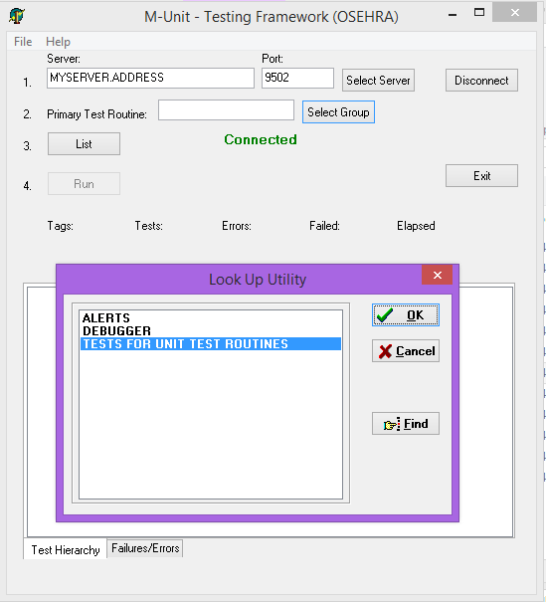

Figure . Selection of an M-Unit test

You could also simply enter the name of a unit test routine in the Primary Test Routine field and click on List (Click on the Clear Group button to clear previous selections). This will bring up a list of the routines and tags in the unit test run (Figure 2).

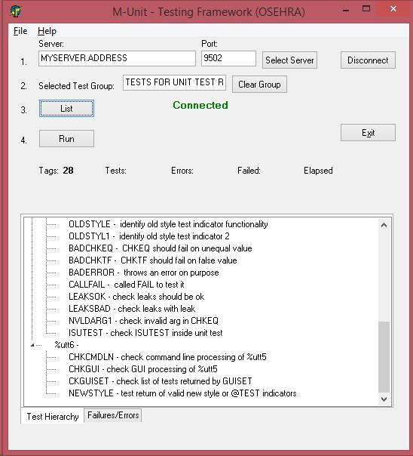

Figure . List of Unit tests selected for running

Clicking the Run button will run the unit tests, resulting in a bar which is green if all tests pass or red if any failures or errors are encountered (Figure 3).

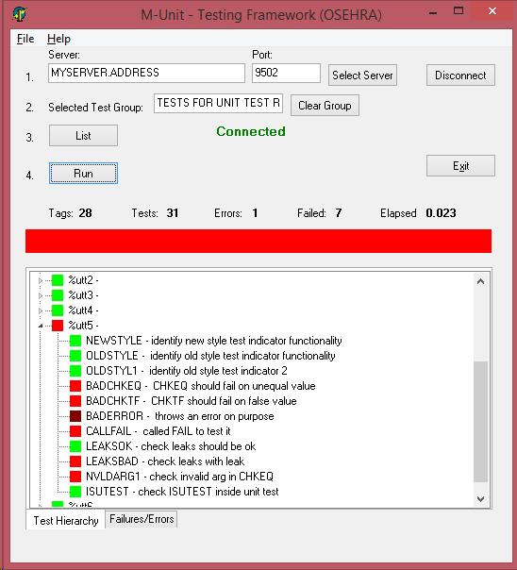

Figure . The unit tests run with failures

If failures or errors are encountered, clicking on the Failures/Errors tab at the bottom of the listing opens a display of specific information on the problems (Figure 4).

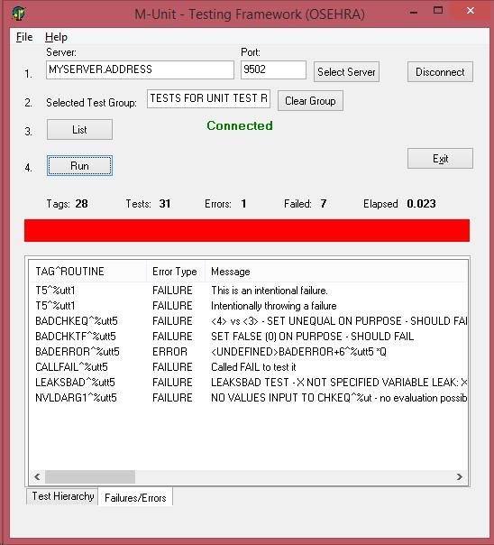

Figure . Specifics on failed tests or errors

In the case shown (Figure 4), all of the failures are intentional. Usually, failures and/or errors are not intentional and the user can then edit the routine, and save the changes, then simply click on the Run button again to see the effect of the changes.

To select a new unit test, the user would click on the Clear Group button, then again either select another group or as shown in Figure 5, entering the name of a unit test routine (ZZUXQA1 and related routines are not included with the M-Unit Test code and is shown only as an example) and clicking on the List button.

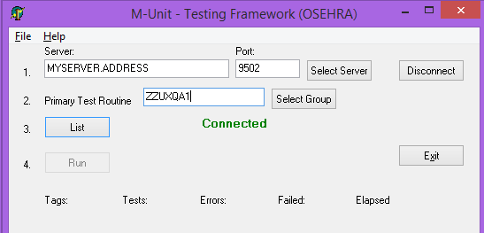

Figure .Specification of unit tests by routine name

Again, clicking the Run button will run the unit tests (Figure 6). This figure shows the desired result, a green bar meaning that all tests passed.

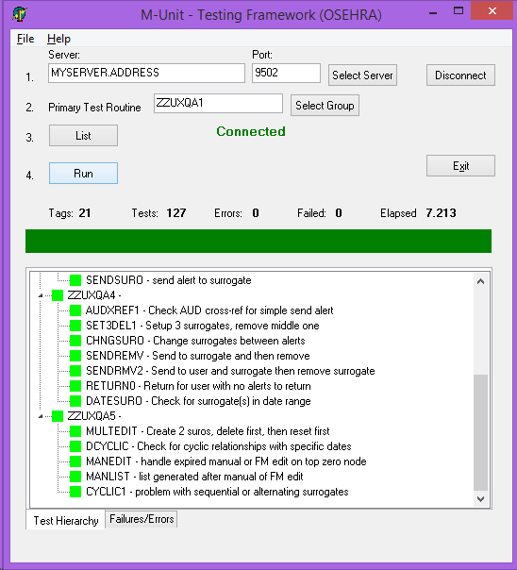

Figure . Result from the second group of unit tests

1. Installation of the M–Unit Software

The installation software for the M–Unit Tools is usually available as either a PackMan message or as a KIDS build file. The basic M–Unit Tools could be loaded from routines only if the usage will be at the command line only (thus not needing the options and remote procedures included in the build).

For installation from a PackMan message:

* open the message and, at the prompt to 'Enter message action', enter X for Xtract KIDS,
* it will then prompt to 'Select PackMan Action', enter 6 for 'INSTALL/CHECK MESSAGE' and follow the subsequent prompts.

For installation from a KIDS build file:

* from the EVE ('System Manager Menu') menu, select:
  + 'Programmer Options'
  + the KIDS ('Kernel Installation & Distribution System') menu
  + and 'Installation', followed by 1 or 'Load a Distribution,'
* at the prompt, enter the host file name (and if using Cache, the directories, if not in the current namespace directory),
* then enter 6 (for 'INSTALL/CHECK MESSAGE') and follow the subsequent prompts.
* The following is an example installation on a Cache system. In a recent version, Sam Habiel provided an update for the preinstall routine (ZZUTPRE) to improve setting the %ut namespace for routines and globals to the current VistA account.

Select Kernel Installation & Distribution System Option: INStallation

Select Kernel Installation & Distribution System Option: INSTallation

Select Installation <TEST ACCOUNT> Option: LOAD a Distribution

Enter a Host File: MASH_1.4_0.KIDS

KIDS Distribution saved on Apr 09, 2016@14:20:48

Comment: Updated M-Unit package

This Distribution contains Transport Globals for the following Package(s):

MASH*1.4*0

Distribution OK!

Want to Continue with Load? YES//

Loading Distribution...

MASH*1.4*0

Use INSTALL NAME: MASH*1.4*0 to install this Distribution.

Select Installation <TEST ACCOUNT> Option: INSTall Package(s)

Select INSTALL NAME: MASH*1.4*0 Loaded from Distribution 4/9/16@14:46:15

=> Updated M-Unit package ;Created on Apr 09, 2016@14:20:48

This Distribution was loaded on Apr 09, 2016@14:46:15 with header of

Updated M-Unit package ;Created on Apr 09, 2016@14:20:48

It consisted of the following Install(s):

MASH*1.4*0

Checking Install for Package MASH*1.4*0

Install Questions for MASH*1.4*0

Incoming Files:

17.9001 M-UNIT TEST GROUP (including data)

Want KIDS to Rebuild Menu Trees Upon Completion of Install? NO//

Want KIDS to INHIBIT LOGONs during the install? NO//

Want to DISABLE Scheduled Options, Menu Options, and Protocols? NO//

Enter the Device you want to print the Install messages.

You can queue the install by enter a 'Q' at the device prompt.

Enter a '^' to abort the install.

DEVICE: HOME// Console (Cache' on Windows)

Install Started for MASH*1.4*0 :

Apr 09, 2016@14:46:59

Build Distribution Date: Apr 09, 2016

Installing Routines:

Apr 09, 2016@14:46:59

Running Pre-Install Routine: ^ZZUTPRE

Installing Data Dictionaries:

Apr 09, 2016@14:47

Installing Data:

Apr 09, 2016@14:47

Installing PACKAGE COMPONENTS:

Installing REMOTE PROCEDURE

Installing OPTION

Apr 09, 2016@14:47

Running Post-Install Routine: ^ZZUTPOST

Routine: ut Loaded, Saved as %ut

Routine: ut1 Loaded, Saved as %ut1

Routine: utcover Loaded, Saved as %utcover

Routine: utt1 Loaded, Saved as %utt1

Routine: utt2 Loaded, Saved as %utt2

Routine: utt3 Loaded, Saved as %utt3

Routine: utt4 Loaded, Saved as %utt4

Routine: utt5 Loaded, Saved as %utt5

Routine: utt6 Loaded, Saved as %utt6

Routine: uttcovr Loaded, Saved as %uttcovr

Updating Routine file...

Updating KIDS files...

MASH*1.4*0 Installed.

Apr 09, 2016@14:47

NO Install Message sent

Install Completed

* Installation on a Linux system is basically the same as shown for Cache. However, the dos2unix command should be run on the KID file first to insure the correct line endings. Also, GT.M will list a number of error messages for Cache specific syntax that it does recognize. These should be ignored.
* As noted below, full captures of installation, running unit tests, and running coverage analysis on the M-Unit package are available as text files.

1. Running M-Unit Tests

Once the installation is complete, you can verify that the %ut test framework has been installed correctly by running the supplied test routines.

There are several routines that can be run to test various areas of the M-Unit functionality. Running the routine %utt1 from the top (i.e, DO ^%utt1) will run the verbose mode of the basic tests. The routine %utt6 when run from the top (DO ^%utt6) or in verbose mode (DO VERBOSE^%utt6) runs a variety of tests for APIs covering the command line, options, and GUI, and the routine %uttcovr is run from the top to perform coverage analysis (only available on GT.M) for the %ut and %ut1 routines. Entering the following command at the VistA command prompt will run the basic tests (and the 7 failures and 1 error are caused on purpose to test specific parts of the code associated with failures and errors):

>D EN^%ut("%utt1")

....

T5^%utt1 - Error count check - This is an intentional failure.

.

T5^%utt1 - Error count check - Intentionally throwing a failure

.............

T1 - Test 1.----------------------------------------------------------- [OK]

T2 - Test 2.----------------------------------------------------------- [OK]

Ran 1 Routine, 2 Entry Tags

Checked 2 tests, with 0 failures and encountered 0 errors.........

BADCHKEQ^%utt5 - CHKEQ should fail on unequal value - <4> vs <3> - SET UNEQUAL

ON PURPOSE - SHOULD FAIL

BADCHKTF^%utt5 - CHKTF should fail on false value - SET FALSE (0) ON PURPOSE -

SHOULD FAIL

BADERROR^%utt5 - throws an error on purpose - Error: <UNDEFINED>BADERROR+6^%utt

5 *Q

CALLFAIL^%utt5 - called FAIL to test it - Called FAIL to test it

LEAKSBAD^%utt5 - check leaks with leak - LEAKSBAD TEST - X NOT SPECIFIED VARIABL

E LEAK: X

NVLDARG1^%utt5 - check invalid arg in CHKEQ - NO VALUES INPUT TO CHKEQ^%ut - no

evaluation possible

................................................................................

Ran 6 Routines, 37 Entry Tags

Checked 113 tests, with 7 failures and encountered 1 error.

>

Full captures of the installation, running DO ^%utt1 [equivalent to EN^%ut("%utt1") since running %utt1 from the top does run that code and then quits] and running DO ^%uttcovr [performing full coverage analysis on the %ut, %ut1, and %utcover routines using the COVERAGE^%ut API) on both GT.M and Cache are available in the documents

160409_CACHE_INSTALL_1.4.0.txt and

160409_GT.M_INSTALL_1.4.0.txt.

These documents and all of the other files are available on the OSEHRA website at:

* <http://code.osehra.org/journal/journal/view/523>

or at:

* <https://github.com/joelivey/M-Unit>

While the results of the coverage for the routine %ut1 show 240 out of 271 lines covered (88.56%) for Cache and 230 out of 271 lines covered (84.87%) for GT.M, the number of lines not covered in both of the operating systems was only 16, resulting in 255 out of 271 lines covered (94.02%) in both of them. The routines %ut and %utcover, both had 100% coverage in both operating systems.

The supplied tests can be run manually, but are also part of the OSEHRA VistA Automated Testing harness. For instructions on how to acquire and run the tests via the OSEHRA harness see the online documentation at:

* <https://github.com/OSEHRA/VistA/blob/master/Documentation/ObtainingTestingCode.rst>
* and <https://github.com/OSEHRA/VistA/blob/master/Documentation/RunningandUploadingTests.rst>

Then execute the following CTest command to run the tests:

ctest -R UNITTEST_Mash_Utilities

1. Clean up the code without changing its behavior, frequently done prior to changing the behavior – see Fowler, M. (1999). *Refactoring: Improving the Design of Existing Code.* Westford, MA: Addison Wesley Longman, Inc.
2. Osherove, R. (2014). *The Art of Unit Testing with Examples in C#, Second Edition.* Shelter Island, NY: Manning Publications Co., p. 34-35.